Matt Bogacz

IT 170

4/12/2020

Program 3 Screenshots

Part 1

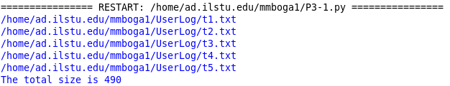

Part 2

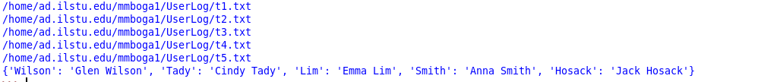

Part 3